Sarah Ann Soldner
June 16, 1877 – April 17, 1898

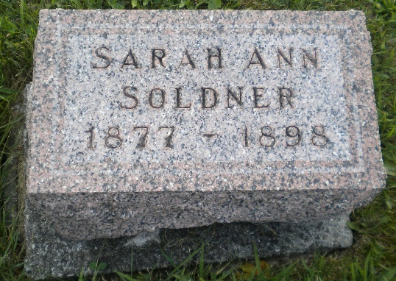
Photo by DSON1492

Indiana, U.S., WPA Death Index, 1882-1920

Name Sarah Soldner
Date Apr 17, 1897
Location Adams County
Age 20 Yr
Gender Female
Race White
Source location County Health Office, Decatur
Source notes The source of this record is the book H-19 on page 196 within the series produced by the Indiana Works Progress Administration.
**

2005 Adams County, Indiana Death Index

Name Soldner, Sarahann
Father Soldner, John J.
Birth 6/16/1877
Death 4/17/1898
Death place Monroe Twp, Adams, IN
Cause of death Consumption
**

Sarah Ann Soldner from tree Stauffer Tree

Birth 1877 Indiana, USA
Residence 1880 Adams, Indiana, USA
Death 17 Apr 1897 Adams, Indiana, USA
Father John J Soldner (1854-1929)
Mother Catherine Huser (1853-1929)
102147 People 3 Records 3 Sources

